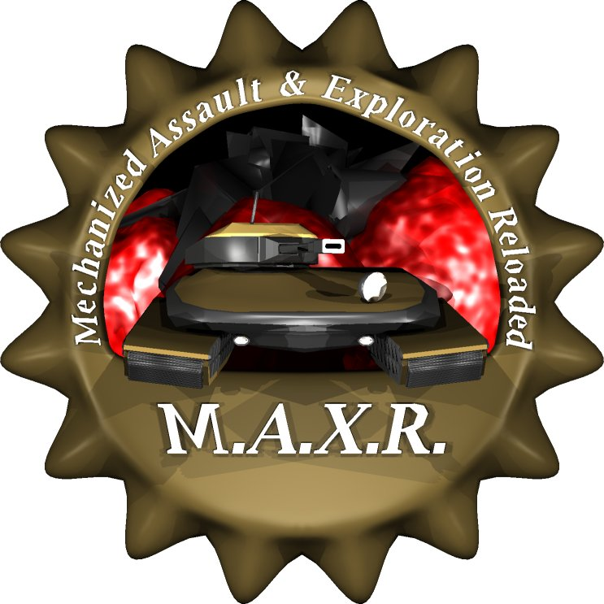

M A N U A L
for maxr 0.2.4
Intro

1. Basics
Building
Surveying

2. Battle

3. Multiplayer
Options
Commands
Hotkeys
Mouse Style

4. Advanced Gameplay (TODO)

5. Mapediting (TODO)

6. License

7. Appendix
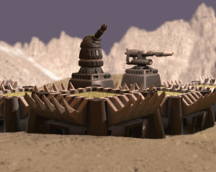
Intro

This guide is for people that don't know the original games MAX I and MAX II. MAXR is a remake of the first MAX game released 1996 by Interplay featuring network games based on TCP/IP (e.g. over the internet). This game was written for all the fans of old school strategy gaming out there.

Unlike most strategy games you may know is MAXR a turn based game. This doesn't however necessary mean that you are doomed to wait and fall asleep while your opponents do their turns. In fact with default settings all players do their moves at the same time. This is called „simultaneous mode“. Keeping in mind that the turn ends clock starts to race to zero when the first player wants to end a turn MAXR can become almost as fast and stressfull like it's realtime relatives.

Another point about MAXR is that this is actually a strategy game. You don't have to care about resources only. While building, upgrading and conquering you have to keep your eyes on munition and materials. Buildings have to be connected at least to power sources and your tanks won't be able to shoot at enemys without ammo. Also keep an eye on your opponents doings. All units in MAXR are the same but unlike in other games you can upgrade each unit absolutly individually. Make sure to counter your enemys technical advances in time before they outrun you with their researches depending on their current strategy.

To achieve your goals a huge fleet with various vehicles is offered to you. You won't need all - it's up to you what you actually want or need. Vehicles don't get out of fashion since it's up to you whether and what you upgrade. Go for long range missiles destroying your enemys before they can even see you or take off to the skies and force your opponents into defence with the most powerful bombers ever.

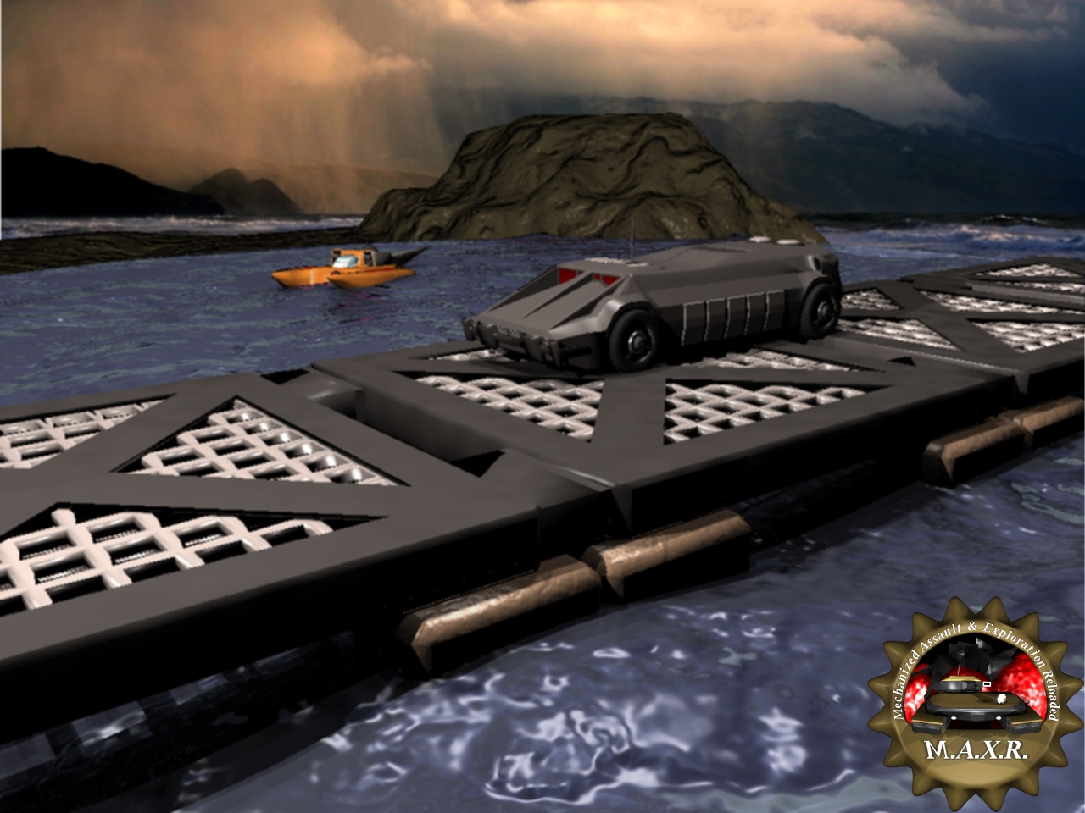
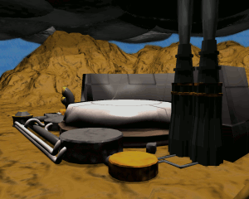
1. Basics

Before you join a game you have to select your landing units. This can be considered as your HQ after your faction drops down to the planet. Choose wisely, since every mistake or miscalculation in the early game stage may lead to sudden defeat. You may also buy some upgrades before the game starts with credits you didn't use on vehicles.

This is the hangar menu. Here you can buy and upgrade your units you want to start with. On the upper left you can see the currents units information picture followed by details and optional descriptions. The details offer upgrade options as well. Simply make use of the arrows behind each values. To upgrade units, that can not be purchased before the game starts, switch into upgrade mode using the button on the lower right.
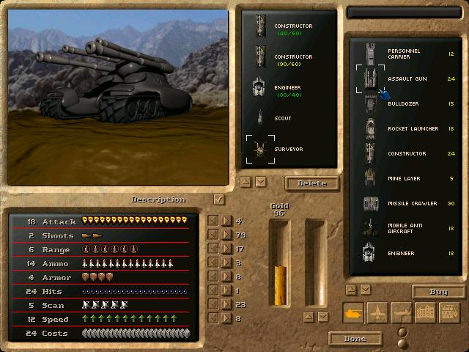
On the right side you see all units that can be purchased or selected. Buttons below the window provide you with filters. That way you can display only ground,- air-, or seaunits. The other two buttons display only buildings or fighting units (including turrets as well).

In the upper middle you can see your current selection. Below you see two bars. One is your credits amount in gold. Each unit or upgrade costs gold. Also does the cargo. When a constructor is selected cargo (materials) can be bought by using the arrows below the bar or by simply clicking on the bar directly.

Make sure to load your constructors with materials or you won't be able to build something. Buy also at least always one constructor, one engineer and one surveyor to be able to expand your base later. Consider buying some basic defending units also. Especially scouts can be a real pain at the beginning of a game.

When you're ready hit the button Done to join the game.
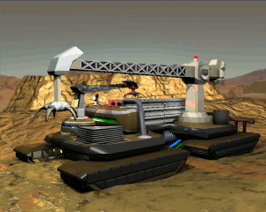

When done with selecting your HQ you'll have to choose a landing position. Your dropship will go down at the selected position. A mining station will be build on the spot providing you with some basic resources. To power the station a small generator will be added automatically. Your HQ units will start spread around the mining station.

Keep in mind that your strategy depends on this step as well. If you are going for the biggest sea power on the map you should start close to water. Keep in mind that opponents might start really close to you as well. If you want to be left in peace for some turns you might consider a small island. Starting in the middle of the map might put you between two other opponents crushing you in the middle later. Starting in a corner may result in a very long way to reach your enemy on the other side.

Take your time for this step. Study the map carefully and make your decision depending on your strategy, starting units and even on your opponents. When done simply click on the point where you wish to start. If the other players are done as well the game will start.
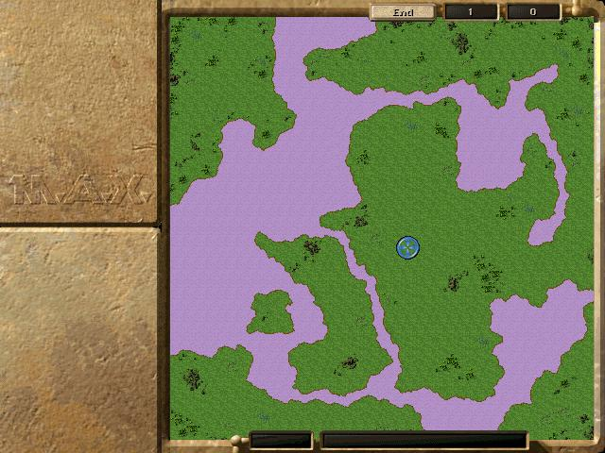
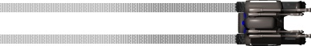
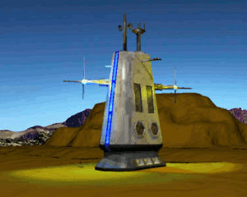
Finally, when the game itself starts, you'll see your base depending on your decisions you made before. Let's go for a small walk through the functions of the GUI first. On the top you'll find the buttons Files and Settings. On the upper right you'll find the End button followed by two boxes with numbers. The End button requests the turn end. Klick this (or simply press Enter) when you're done with your actions. The first box represents the current turn. The second box will start a countdown, when the turn end was initiated. When all players requested the turn end the countdown will reach zero at once.

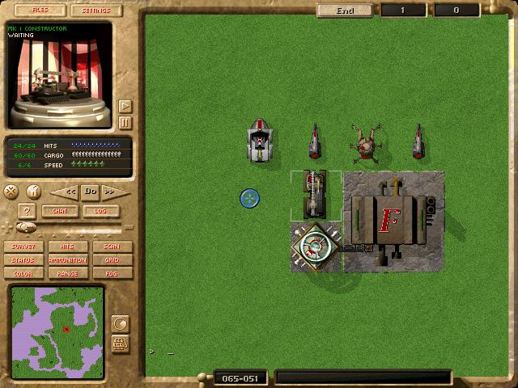
On the lower side we start with the mini map and it's functions to the right. The next two boxes show your currents position on the map's grid and informations about the unit currently under your cursor.

The left side is split up in two parts. The upper part shows details about the current selected unit including the most important informations like health, action points, munition and so on. The vehicle's video can be paused if the spinning irritates to much. The lower part holds dialogs or settings for keeping an overview of the map and game itself. Click around and try it for yourself. The most useful buttons are Scan, Range and Fog. There's also a Chat button (Tab activates chat mode as well) it you feel chatty.

You may notice that there is nothing like your amount of materials or build- or attackbuttons. To request such informations or actions simply click on the unit that has something to do with the desired action. For example if you want to know how much materials you have simply click on a mining station or a storage. Double clicking on a unit will pop up it's context menu. To build something select a construction unit or factory and choose the build button in the context menu.

To scroll the map simple move the cursor to the borders of the screen, use or arrows or click on the mini map as you may know it from similar games.
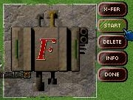
Let's do something already. In the middle of the screen you'll find your first mining station attached to a small generator. First you should start mining to get more materials every turn. To do so double click on the mining station and choose the Start button. The station starts mining with some flashing lights. You may also notice that the generator beside the station started to work as well. All buildings in MAXR request energy to work. Energy is provided by generators that need fuel to operate. Your mining station mines fuel as well. More on this later.

If you read the manual carefully you should have at least one constructor and one engineer. Locate the engineer and check whether it has raw materials in the details field below the vehicle's video. Select Build from the context menu. The build screen pops up.

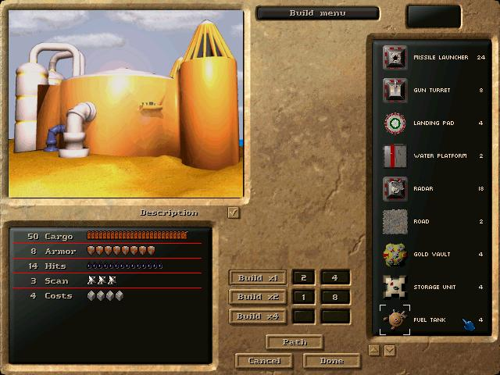
The engineer is capable of various small buildings including defence types and structures like roads and bridges. The menu works very similar to the hangar menu. Search and choose the fuel tank in the menu on the right. In the lower middle you can select the building speed. Notice that constructing at higher speed increases the material need for the building significant. Leave the speed at Build x1 and hit the Done button. The engineer starts building a fuel tank at it's current position now. The building will be finished in two rounds.

Here is something special for MAXR. Each building has to be connected to at least a power source to work. To connect buildings you have to build connectors. A connector can be considered as a big pipe allowing materials, fuel, energy and even gold to flow. Only buildings connected to other buildings can receive things they need to function proper. In our example you have to connect the fuel tank to the mining station to store fuel that's not needed by the generator each turn. Unneeded materials of any kind are lost if they can't be stored! A building is however automatically connected to a building next to it.
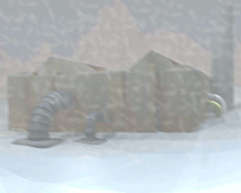
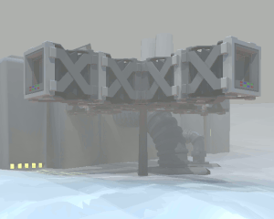
This is an excellent time to start searching for more resources. Locate your surveyor and click on it. You may notice some circles on the map now. This is the Survey mode, that can be accessed clicking on the Survey button over the mini map as well. The surveyor scans for minerals automatically. Move it around a little bit and see what happens.

The circles with colours indicate resources. White is for raw material. Green is for fuel. Yellow is for gold. The amount is displayed directly on the circle. Blank circles represent no resources at a field. Resources usually group in fields that have to be found first. When found a mining station can be build upon to access the resources. You may notice, that the mining station you started with holds some resources for fuel and material.


You don't have to move the surveyor around on your own all the time. Open it's context menu and choose the Auto option. The surveyor will now start to search for resources automatically. Watch him doing so and check your Survey map regularly to identify good spots for mining stations.

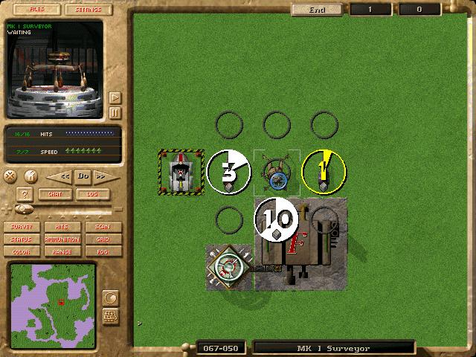
Mining stations, and other huge buildings, can only be build by a constructor. This vehicle is most important at the beginning. Make sure no roaming scout destroys it. Without a huge vehicle factory you won't be able to create a new one.

When a good spot for a mining station is found simple drive with the construction vehicle to the spot. Keep in mind that huge buildings need more space. Build a second mining station to gain more resources and connect it using connectors to your first station. Also build another power generator to power the second station as well.

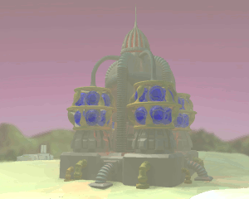
End the turn if you're done with all your actions for a round. Each round you'll gain some resources. Action points will be refreshed and units built. When a building is finished a green box around it will start to flash. Click on the construction vehicle and move it to an exit point. The new building will appear. Notice that the constructor's materials will decrease with every building.
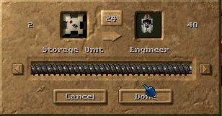
To reload a construction vehicle's cargo use the X-FER command available from storages and mining stations. The vehicle has to stand next to a connector or a building connected to the material source for a transfer.

After some turns you should have a small base established. Make sure you have enough energy for all your buildings. Click on a generator to find out. Also make sure you have always enough fuel for your generators. A generator without fuel will stop working. Buildings depending on that generator will stop working too. This can cause a chain reaction stopping even your mining stations.

To check your resource income open the allocation menu from the context menu of a mining station.

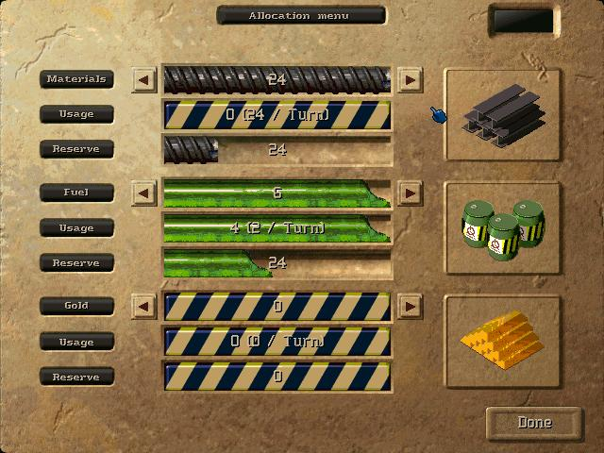
Each station can dig for 16 resources each turn. If a resource spot provides more than 16 resources you have to choose the preferred resources manually. The allocation menu represents all mining stations connected to the current base. Increase or decrease sliders to select what resources should be mined for.

With this knowhow you should now be able to expand your base with factories. Construct defence turrets and consider roads for your vehicles to reach the frontline faster. Make sure to connect buildings using connectors with your base.
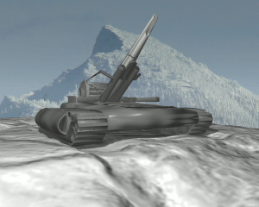
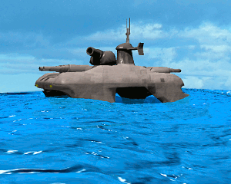
2 Battle

So this is what you've been waiting for. The enemy shows up and claims your planet for himself. Luckily you brought some tanks along as well.

To issue an attack simply select a fighting vehicle and click on an opponent in reach. Depending on the units range and weapon type it will attack the opponent automatically. Keep in mind that you have to see your enemy to shoot at him. Use scanners and scouts to find your enemys and long range weapons like the missile launcher to destroy them.

To find out about scanning and firing ranges of your units open the information dialog of the vehicle using Info from it's context menu. You can display each units scanning and firing range on the map as well. To do so simply click on the buttons Scan and Range below the units status informations on the HUD on the left side of the screen.

Some units can't shoot when they moved in the same turn. Others can always fire a shot – or perhaps at least one. Each shot takes munition that has to be refilled in time. The ability to shoot on an enemy depends on the weapon type of the vehicle too. Most units can't attack air planes like the bomber. Some units can only attack planes. You'll find out about this quickly. Read the unit descriptions carefully to find out what each unit might be good for.

Each unit is a specialist in something. Whether fast, strong or destructive depends on it's values. Each value can be upgraded individually. It's completely up to you and your strategy what style of combat you're going for – and whether your opponents plays his part too.

Calculation for damage is done really simple. Take the attack value, subtract the targets armor and you'll get the hitpoints removed from your target. In MAXR warfare is completely mechanized. Your unit will always hit the weakest point of your enemies. Neither wind nor camouflage will have any effect on this. To see how much damage can be issued simply check the attack cursor itself. While holding the cursor over an enemy unit you can read from the cursor's health bar how much damage your shot will issue.

Special units are infiltrators. These human units can only be seen from other humans like the infantery as long as they don't do a mistake. Use them to spy on your enemy, disable units or even steal an enemy vehicle by hacking it. Make use of infantery to detect enemy infiltrators threatening your faction. Infiltrators can also gain experience advancing their chances on success for disabling or stealing. There are more stealth units like the APC (under water) or the submarine. Both can be detected and attacked by a corvet. Bombers and other submarines can also attack submarines and APCs.

Remember that submarines will become visible when they shoot until they change their position. Units don't have to be seen or detected to get hit by a lucky shoot. You can always guess that an enemy is around and cover a field with fire manually – devastating for mines or infiltrators with e.g. a cluster since a cluster will damage several fields around the targeted hot spot as well.

Keep in mind that your enemy will probably advance his favored units depending on his strategy quickly. For example a bomber with increased range will exceed your anti air turrets easily. Be prepared for surprises and cover weak points in your defence with mobile units. Also keep always a repair unit and a material truck around to repair and refill your vehicles in action.
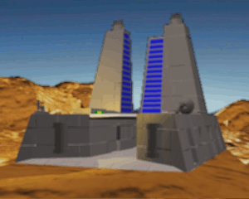
3 Multiplayer

Well, this is what MAXR is all about. Bored by the AI or done with unstable IPX games in MAX? Let's play against human opponents using TCP/IP and therefore the internet. Starting a game is sort of easy. Unfortunately MAXR doesn't feature a lobby of some sort. When you start a game you have to tell your friends your IP address and make sure the default port 58600 is reachable from the outside. Configure your router and perhaps teach your firewall about this.

You can find out your computer's IP by issuing the command „ipconfig“ on windows. Usually it will report something like 192.168.1.*. Now connect to your router's admin panel (usually with http://192.168.1.1 or something like that depending on your local subnets IP area in your webbrowser) and map the default port 56800 for MAXR to your local computer. TCP/IP is enough – there's no need to map UDP too. Make sure that no firewall on your local computer blocks MAXR or the port 56800. Now learn about your IP from the outside. It's usually hidden somewhere within the admin panel of your router as well. Share this IP with your friends when running a server.

If everything is prepared use the button TCP/IP Host in the menu Multiplayer to start a new game.
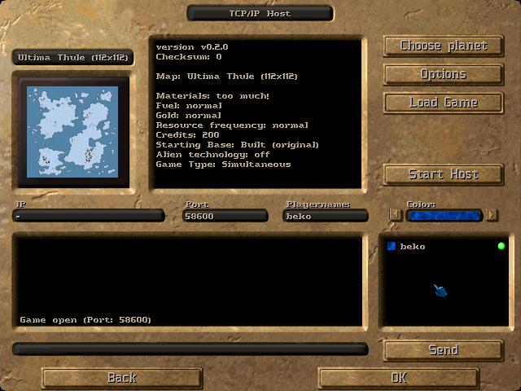
To open the server hit the button Start Host. Once done people can connect to your game. Joining a game is very similar. For this you have to enter the menu TCP/IP Client instead. Fill in the IP and port number of a running server and hit the button Connect arranged at the same position you'd start a server when hosting a game.

The hoster is able to Choose Planet (map for the match) and to set some Options for the game. Remember that all players have to have the selected map installed and should play with the same version of MAXR. Use the chatbox if you feel chatty. To change your player's name simply enter a new nick in the field playername. To change the colour for your player use the arrows beside the color field. Once all players are ready you can start the game hitting OK. To change the player status into ready each player has to click on the tiny red button behind his name in the box containing all connected players. Alternatively you may use the chat command /ready as well. Hitting Back will terminate the server or connection .
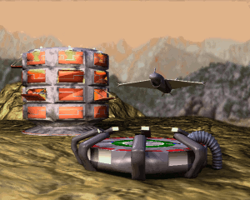
Option in detail

Options are separated in six fields. Each field is grouped in option types. Options are set in a multiple choice type. Select a new option by clicking on it and another option is deselected automatically. Let's go through the options from left to right and upper to lower.
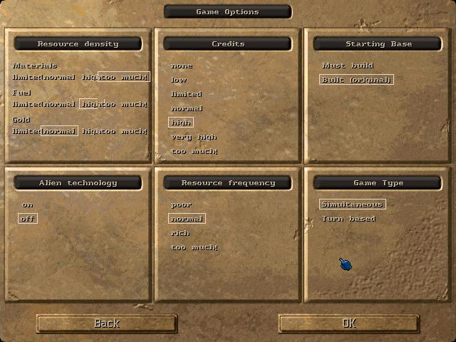

Resource density:

Here you can set the density of resources found on a resource spot. Increasing the density will result in rich fields. If you are new to MAXR or wish for a fast game with lots and lots of units choose for example very much materials. This raises the chances for up to 16 materials on one single spot. The same goes for fuel and gold.

Credits:

The credits represent your starting money. Units and upgrades can be bought with them in the hangar menu before the game starts. Not used credits are lost. Remember that many credits mean as well many possible units or powerful units at game start. This is dangerous if your opponent starts close by and likes to rush early. This is nice if you're just out for a small skirmish. Use low credits for difficult and long lasting starting phases.

Starting Base:

This setting controls whether the base is already built or whether you have to look for a good spot first and start building your base all by yourself. The base consists out of a factory and a small generator to power it. Choose no base if you just wish for fast skirmish games. In this case you may leave out any constructing units and start with a fleet of basic ground units – some perhaps upgraded. Search your opponents with that fleet. Dominate or get destroyed.

Alien Technologie:

Enable or disable units and buildings considered as alien – e.g. not human.

Resource Frequency:

The frequency of resource spots found on the map is set by this value. Many resource spots means many resources in game. You'll be able to build mines very close to each other without looking long for a good spot.

Game Type:

Whether the game will be turn based or simultaneous is set here. MAXR is a turn based game but usually all players move at the same time. This is called „simultaneous mode“. If you like the traditional style more and prefer to wait until your opponents completely finished their moves (and wait for yours) choose the turn based mode instead.

Other options will be available soon.
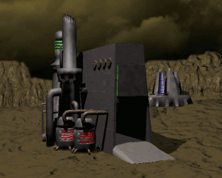
Commands

The ingame console offers a variet of commands for debugging or information purposes. Simply bring up the chat (Tab or Chat button) and enter one of the following commands:

/base [server/client/off] | shows details of the client or the server* to bases
/sentry [server/off] | shows covered areas by unity on sentry
/fx [on/off] | shows additional information to special effects
/trace [server/client/off] | shows additional information of the client or the server* about current field
/ajobs [on/off] | shows additional information about attackjobs
/players [on/off] | shows additional information about all players (with ids) in the game
/resync [id] | resyncs all units of the player with the overgiven number or all players if no number was set.
/kick [id] | removes a player from the game.
/disconnect [id] | closes connection to a player and starts waiting for reconnection.
/deadline <seconds> | sets deadline for turnend to given seconds
/fps | shows frames per second
/com [on/off] | [*not working*] shows network traffic (multiplayer)
/log [on/off] | [*not working*] creates a logfile by engine
/[show/hide] log | [*not working*] shows log (if active)
/ping | [*not working*] checks connectivity in multiplayer

* only available on the host/server

The next commands are considered as cheats and work only on the host or in singleplayer:

/survey | shows all resources
/color [0-7] | sets new color for active player
/fog off | disabled fog for a short period
/credits | [*not working*] player gets +1000 credits
/kill [x] [y] | [*not working*] kills whatever is on position x,y
/god off | [*not working*] creates a godless world
/load | [*not working*] reloads active unit

Other commands will follow soon.

Hotkeys

MAXR offers a set of hotkeys. Most keys can be defined in the file keys.xml.

F1 | Go to event
F2 | Issue player kick for disconnected player (server only)
F5-F8 | Jump to saved screen position
Alt+F5 – Alt+F8 | Save current screen position
Alt+C | Take a screenshot
Arrows | Scroll map
+ / - (also mouse wheel) | Zoom map
Enter | Turn end
Tab | Chat / Console
N | Fog on/off
G | Grid on/off
S | Scan on/off, stop, start, sentry, steal
R | Range on/off, reload, repair, research
M | Munition on/off
T | Hitpoints on/off
F | Color on/off
A | Attack, automove, acticate
B | Build menu
X | Xfer menu
C | Clear, clear mine
L | Load, lay mine
D | Disable, distribution menu, destroy
U | Upgrade
L-Shift | [*not working*] calculate path without moving
ESC | Exit, end game

Mouse Style

You have to edit keys.xml if you want to switch between classic and modern mouse input methods. The classic style behaives more like in the original MAX.

To change to the classic input style open keys.xml and change the MOUSE_STYLE to OLDSCHOOL

<Mouse>
<MOUSE_STYLE Text="OLDSCHOOL"/>
</Mouse>

To change to the modern input style open keys.xml and change the MOUSE_STYLE to MODERN

<Mouse>
<MOUSE_STYLE Text="MODERN"/>
</Mouse>

4. Advanced Gameplay

(TODO)

5. Mapediting

(TODO)

6 License

MAXR is released under the GPL. You can read the online version at http://www.gnu.org/licenses/gpl.html

GNU GENERAL PUBLIC LICENSE  Version 2, June 1991  Copyright (C) 1989, 1991 Free Software Foundation, Inc.  51 Franklin St, Fifth Floor, Boston, MA 02110-1301 USA  Everyone is permitted to copy and distribute verbatim copies  of this license document, but changing it is not allowed.  Preamble  The licenses for most software are designed to take away your  freedom to share and change it. By contrast, the GNU General Public  License is intended to guarantee your freedom to share and change free  software--to make sure the software is free for all its users. This  General Public License applies to most of the Free Software  Foundation's software and to any other program whose authors commit to  using it. (Some other Free Software Foundation software is covered by  the GNU Library General Public License instead.) You can apply it to  your programs, too.  When we speak of free software, we are referring to freedom, not  price. Our General Public Licenses are designed to make sure that you  have the freedom to distribute copies of free software (and charge for  this service if you wish), that you receive source code or can get it  if you want it, that you can change the software or use pieces of it  in new free programs; and that you know you can do these things.  To protect your rights, we need to make restrictions that forbid  anyone to deny you these rights or to ask you to surrender the rights.  These restrictions translate to certain responsibilities for you if you  distribute copies of the software, or if you modify it.  For example, if you distribute copies of such a program, whether  gratis or for a fee, you must give the recipients all the rights that  you have. You must make sure that they, too, receive or can get the  source code. And you must show them these terms so they know their  rights.  We protect your rights with two steps: (1) copyright the software, and  (2) offer you this license which gives you legal permission to copy,  distribute and/or modify the software.  Also, for each author's protection and ours, we want to make certain  that everyone understands that there is no warranty for this free  software. If the software is modified by someone else and passed on, we  want its recipients to know that what they have is not the original, so  that any problems introduced by others will not reflect on the original  authors' reputations.  Finally, any free program is threatened constantly by software  patents. We wish to avoid the danger that redistributors of a free  program will individually obtain patent licenses, in effect making the  program proprietary. To prevent this, we have made it clear that any  patent must be licensed for everyone's free use or not licensed at all.  The precise terms and conditions for copying, distribution and  modification follow.  GNU GENERAL PUBLIC LICENSE  TERMS AND CONDITIONS FOR COPYING, DISTRIBUTION AND MODIFICATION  0. This License applies to any program or other work which contains  a notice placed by the copyright holder saying it may be distributed  under the terms of this General Public License. The "Program", below,  refers to any such program or work, and a "work based on the Program"  means either the Program or any derivative work under copyright law:  that is to say, a work containing the Program or a portion of it,  either verbatim or with modifications and/or translated into another  language. (Hereinafter, translation is included without limitation in  the term "modification".) Each licensee is addressed as "you".  Activities other than copying, distribution and modification are not  covered by this License; they are outside its scope. The act of  running the Program is not restricted, and the output from the Program  is covered only if its contents constitute a work based on the  Program (independent of having been made by running the Program).  Whether that is true depends on what the Program does. | 1. You may copy and distribute verbatim copies of the Program's  source code as you receive it, in any medium, provided that you  conspicuously and appropriately publish on each copy an appropriate  copyright notice and disclaimer of warranty; keep intact all the  notices that refer to this License and to the absence of any warranty;  and give any other recipients of the Program a copy of this License  along with the Program.  You may charge a fee for the physical act of transferring a copy, and  you may at your option offer warranty protection in exchange for a fee.  2. You may modify your copy or copies of the Program or any portion  of it, thus forming a work based on the Program, and copy and  distribute such modifications or work under the terms of Section 1  above, provided that you also meet all of these conditions:  a) You must cause the modified files to carry prominent notices  stating that you changed the files and the date of any change.  b) You must cause any work that you distribute or publish, that in  whole or in part contains or is derived from the Program or any  part thereof, to be licensed as a whole at no charge to all third  parties under the terms of this License.  c) If the modified program normally reads commands interactively  when run, you must cause it, when started running for such  interactive use in the most ordinary way, to print or display an  announcement including an appropriate copyright notice and a  notice that there is no warranty (or else, saying that you provide  a warranty) and that users may redistribute the program under  these conditions, and telling the user how to view a copy of this  License. (Exception: if the Program itself is interactive but  does not normally print such an announcement, your work based on  the Program is not required to print an announcement.)  These requirements apply to the modified work as a whole. If  identifiable sections of that work are not derived from the Program,  and can be reasonably considered independent and separate works in  themselves, then this License, and its terms, do not apply to those  sections when you distribute them as separate works. But when you  distribute the same sections as part of a whole which is a work based  on the Program, the distribution of the whole must be on the terms of  this License, whose permissions for other licensees extend to the  entire whole, and thus to each and every part regardless of who wrote it.  Thus, it is not the intent of this section to claim rights or contest  your rights to work written entirely by you; rather, the intent is to  exercise the right to control the distribution of derivative or  collective works based on the Program.  In addition, mere aggregation of another work not based on the Program  with the Program (or with a work based on the Program) on a volume of  a storage or distribution medium does not bring the other work under  the scope of this License.  3. You may copy and distribute the Program (or a work based on it,  under Section 2) in object code or executable form under the terms of  Sections 1 and 2 above provided that you also do one of the following:  a) Accompany it with the complete corresponding machine-readable  source code, which must be distributed under the terms of Sections  1 and 2 above on a medium customarily used for software interchange; or,  b) Accompany it with a written offer, valid for at least three  years, to give any third party, for a charge no more than your  cost of physically performing source distribution, a complete  machine-readable copy of the corresponding source code, to be  distributed under the terms of Sections 1 and 2 above on a medium  customarily used for software interchange; or,  c) Accompany it with the information you received as to the offer  to distribute corresponding source code. (This alternative is  allowed only for noncommercial distribution and only if you  received the program in object code or executable form with such  an offer, in accord with Subsection b above.)
The source code for a work means the preferred form of the work for  making modifications to it. For an executable work, complete source  code means all the source code for all modules it contains, plus any  associated interface definition files, plus the scripts used to  control compilation and installation of the executable. However, as a  special exception, the source code distributed need not include  anything that is normally distributed (in either source or binary  form) with the major components (compiler, kernel, and so on) of the  operating system on which the executable runs, unless that component  itself accompanies the executable.  If distribution of executable or object code is made by offering  access to copy from a designated place, then offering equivalent  access to copy the source code from the same place counts as  distribution of the source code, even though third parties are not  compelled to copy the source along with the object code.  4. You may not copy, modify, sublicense, or distribute the Program  except as expressly provided under this License. Any attempt  otherwise to copy, modify, sublicense or distribute the Program is  void, and will automatically terminate your rights under this License.  However, parties who have received copies, or rights, from you under  this License will not have their licenses terminated so long as such  parties remain in full compliance.  5. You are not required to accept this License, since you have not  signed it. However, nothing else grants you permission to modify or  distribute the Program or its derivative works. These actions are  prohibited by law if you do not accept this License. Therefore, by  modifying or distributing the Program (or any work based on the  Program), you indicate your acceptance of this License to do so, and  all its terms and conditions for copying, distributing or modifying  the Program or works based on it.  6. Each time you redistribute the Program (or any work based on the  Program), the recipient automatically receives a license from the  original licensor to copy, distribute or modify the Program subject to  these terms and conditions. You may not impose any further  restrictions on the recipients' exercise of the rights granted herein.  You are not responsible for enforcing compliance by third parties to  this License.  7. If, as a consequence of a court judgment or allegation of patent  infringement or for any other reason (not limited to patent issues),  conditions are imposed on you (whether by court order, agreement or  otherwise) that contradict the conditions of this License, they do not  excuse you from the conditions of this License. If you cannot  distribute so as to satisfy simultaneously your obligations under this  License and any other pertinent obligations, then as a consequence you  may not distribute the Program at all. For example, if a patent  license would not permit royalty-free redistribution of the Program by  all those who receive copies directly or indirectly through you, then  the only way you could satisfy both it and this License would be to  refrain entirely from distribution of the Program.  If any portion of this section is held invalid or unenforceable under  any particular circumstance, the balance of the section is intended to  apply and the section as a whole is intended to apply in other  circumstances.  It is not the purpose of this section to induce you to infringe any  patents or other property right claims or to contest validity of any  such claims; this section has the sole purpose of protecting the  integrity of the free software distribution system, which is  implemented by public license practices. Many people have made  generous contributions to the wide range of software distributed  through that system in reliance on consistent application of that  system; it is up to the author/donor to decide if he or she is willing  to distribute software through any other system and a licensee cannot  impose that choice.  This section is intended to make thoroughly clear what is believed to  be a consequence of the rest of this License.  8. If the distribution and/or use of the Program is restricted in  certain countries either by patents or by copyrighted interfaces, the  original copyright holder who places the Program under this License  may add an explicit geographical distribution limitation excluding  those countries, so that distribution is permitted only in or among  countries not thus excluded. In such case, this License incorporates  the limitation as if written in the body of this License. | 9. The Free Software Foundation may publish revised and/or new versions  of the General Public License from time to time. Such new versions will  be similar in spirit to the present version, but may differ in detail to  address new problems or concerns.  Each version is given a distinguishing version number. If the Program  specifies a version number of this License which applies to it and "any  later version", you have the option of following the terms and conditions  either of that version or of any later version published by the Free  Software Foundation. If the Program does not specify a version number of  this License, you may choose any version ever published by the Free Software  Foundation.  10. If you wish to incorporate parts of the Program into other free  programs whose distribution conditions are different, write to the author  to ask for permission. For software which is copyrighted by the Free  Software Foundation, write to the Free Software Foundation; we sometimes  make exceptions for this. Our decision will be guided by the two goals  of preserving the free status of all derivatives of our free software and  of promoting the sharing and reuse of software generally.  NO WARRANTY  11. BECAUSE THE PROGRAM IS LICENSED FREE OF CHARGE, THERE IS NO WARRANTY FOR THE PROGRAM, TO THE EXTENT PERMITTED BY APPLICABLE LAW. EXCEPT WHEN OTHERWISE STATED IN WRITING THE COPYRIGHT HOLDERS AND/OR OTHER PARTIES PROVIDE THE PROGRAM "AS IS" WITHOUT WARRANTY OF ANY KIND, EITHER EXPRESSED OR IMPLIED, INCLUDING, BUT NOT LIMITED TO, THE IMPLIED WARRANTIES OF MERCHANTABILITY AND FITNESS FOR A PARTICULAR PURPOSE. THE ENTIRE RISK AS TO THE QUALITY AND PERFORMANCE OF THE PROGRAM IS WITH YOU. SHOULD THE PROGRAM PROVE DEFECTIVE, YOU ASSUME THE COST OF ALL NECESSARY SERVICING, REPAIR OR CORRECTION.  12. IN NO EVENT UNLESS REQUIRED BY APPLICABLE LAW OR AGREED TO IN WRITING WILL ANY COPYRIGHT HOLDER, OR ANY OTHER PARTY WHO MAY MODIFY AND/OR REDISTRIBUTE THE PROGRAM AS PERMITTED ABOVE, BE LIABLE TO YOU FOR DAMAGES, INCLUDING ANY GENERAL, SPECIAL, INCIDENTAL OR CONSEQUENTIAL DAMAGES ARISING OUT OF THE USE OR INABILITY TO USE THE PROGRAM (INCLUDING BUT NOT LIMITED TO LOSS OF DATA OR DATA BEING RENDERED INACCURATE OR LOSSES SUSTAINED BY YOU OR THIRD PARTIES OR A FAILURE OF THE PROGRAM TO OPERATE WITH ANY OTHER PROGRAMS), EVEN IF SUCH HOLDER OR OTHER PARTY HAS BEEN ADVISED OF THE POSSIBILITY OF SUCH DAMAGES.  END OF TERMS AND CONDITIONS

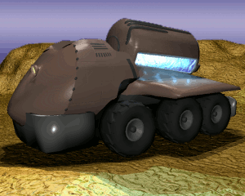
7. Appendix

Over the years a lot of projects around the original game MAX where started. This is to clear the confusion about several projects. I'll try to list every project I know about in an alphabetic order without taking care of targeted operating system, license or coding language as good as I know. Please let me know about further informations or mistakes!

Artlav's M.A.X. | Prior stopped clone project of M.A.X. resurrected in M.A.X.G.
Barlogg's M.A.X. | Prior stopped clone project of M.A.X. resurrected in M.A.X.G.
M.D.V. | M.A.X. clone by Didi written in basic still in the early beginning
M.A.X. | Mechanized Assault and Exploration – Interplay's original
M.A.X. II | Official sequel of M.A.X. by Interplay
MM's M.A.X. | Early version of M.A.X.R. written by M. Mönch
M.A.X.G. | M.A.X. Gold is a rewritten and expanded clone of M.A.X. by the russian MAX-Club mostly written by Artlav to play by mail
M.A.X.R. | M.A.X. Reloaded, this M.A.X. clone written by community of maxthegame.de featuring TCP/IP
U.M.A.X. | Attempt for a M.A.X. clone from france – sadly inactive for years

Unlike other clones MAXR aims primary for multiplayer over TCP/IP on any common operating system currently in use. It runs on Linux, Mac and Windows as well thanks to the SDL libraries available on all three operating systems. Additional the original game data isn't needed to play M.A.X.R. - a free alternative graphic set makes this possible. However for the original look and feel and optional stuff like sounds, music or videos an original game cd of M.A.X. is needed. The tool „Resinstaller“ coming along with M.A.X.R. extracts all this data automatically. MAXR doesn't feature AI (yet?). If you want to play against your computer check out various reports about running MAX with „dosemu“ or „dosbox“ on modern operating systems.

It's easy to expand MAXR with new units or translations. The file formats for units, translations and even save games are kept in readable XML and can be modified or expanded. Check out the bbs at http://www.maxthegame.de/bbs and join the community for playing or hacking MAXR or simply drop by on the IRC at irc.freenode.net channel #maxr

